Practical 10: AI Text Bias & Plagiarism
Aim :- To analyse AI generated text for plagiarism and bias.
Objectives
• To detect biased statements
• To improve writing
Materials Required
• ChatGPT / Gemini
• Grammarly
Procedure
1. Generate paragraph from AI – Use an AI writing tool to produce a clear, coherent paragraph on your chosen topic.
2. Check plagiarism – Run the paragraph through a plagiarism checker to ensure originality and proper attribution.
3. Check grammar – Review the text with a grammar tool to correct errors in punctuation, spelling, and sentence structure.
4. Identify biased statements – Examine the content for subjective language, assumptions, or one-sided viewpoints.
5. Rewrite neutrally – Revise the paragraph to remove bias, ensuring the tone is balanced, objective, and fact-based.
Before:-
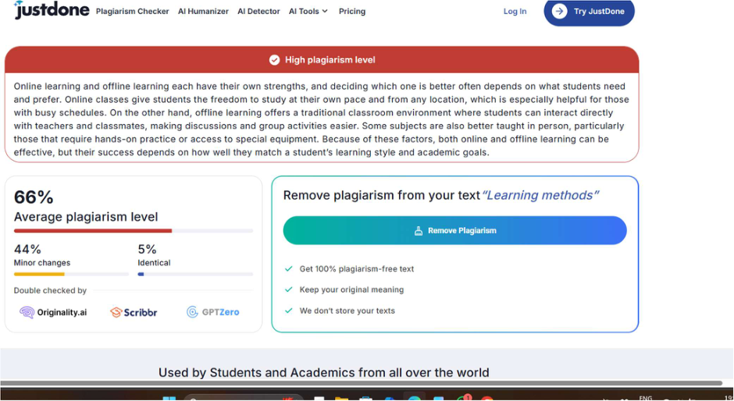

AFTER:-
